

JK LAKSHMIPAT UNIVERSITY

DIGITAL CIRCUIT AND SYSTEMS  
(EE1120)

Activity 07

4 – Bit Adder using VHDL language.

Date : 5th March 2024

Name : Bobby Sharma

Roll no. = 2023BTECH023

# AIM: Design and Simulation of Full Adder using HA (Structural Modelling) using VHDL language using Xilinx ISE Tool.

SOFTWARE REQUIRED: Xilinx ISE tool in your device.

THEORY:

Combinational circuits that can add two binary digits (bits) and a carry bit and produces a sum bit and a carry bit as output is known as a **full adder**.

In other words, a combinational circuit which is designed to add three binary digits and produces two outputs (sum and carry) is known as a full adder. Thus, a full adder circuit adds three binary digits, where two are the inputs and one is the carry forwarded from the previous addition. The block diagram and circuit diagram of the full adder are shown in Figure-1.

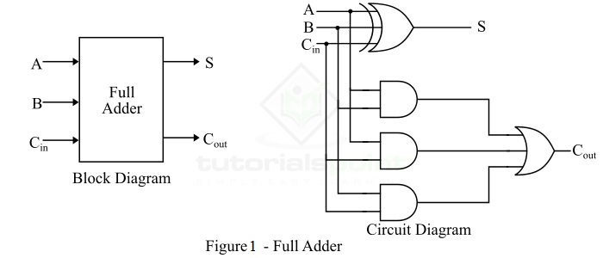

Hence, the circuit of the full adder consists of one EX-OR gate, three AND gates and one OR gate, which are connected as shown in the full adder circuit in Figure-1.

OBSERVATION: The observed outputs of all the basic gates are as follows:

* FULL ADDER:

VHDL Code: RTL Diagram:

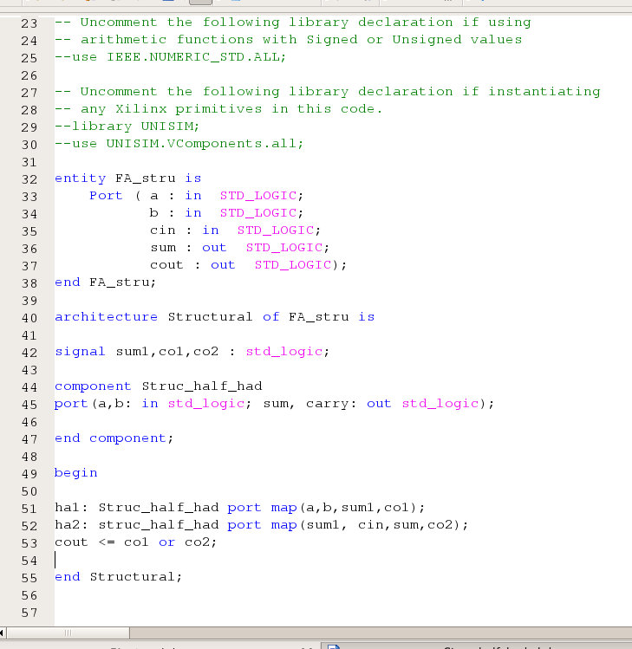 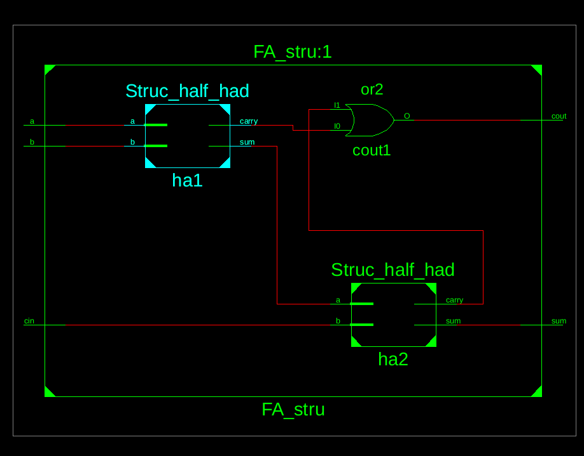

Figure 2 Figure 3

Test Bench Code:

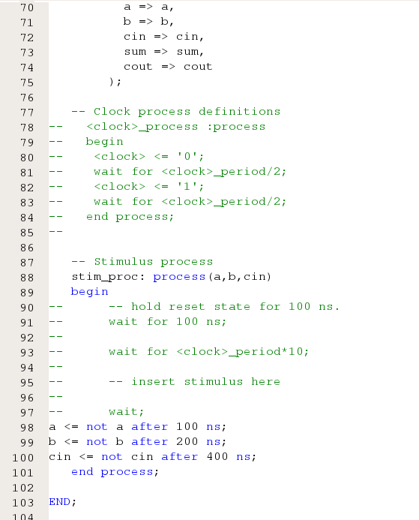

Figure 4

Waveform:

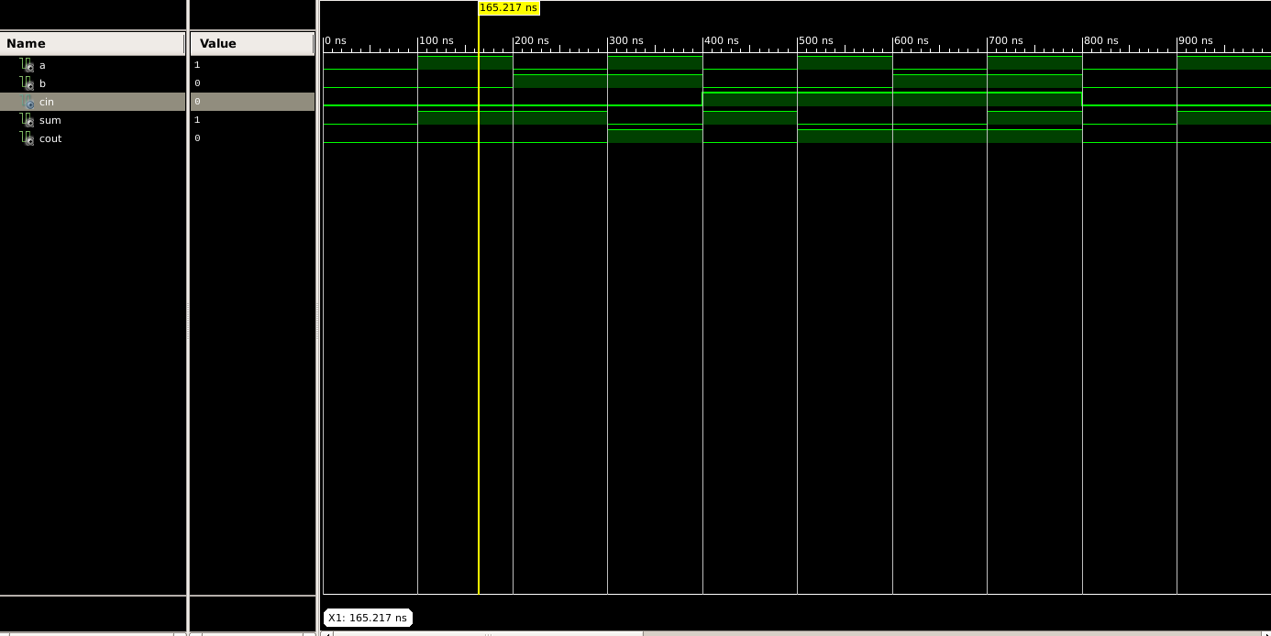

Figure 5

Here the yellow line in figure 5 represents the input (a=1, b=0 and carry(in)=0) and output(sum = 1 and carry(out) = 0). In which we can see the change of input signals of and b after every 100, 200 and 400 nano seconds respectively.

The truth table for a full adder using half adder (structural modelling) lists all possible combinations of inputs (A, B, and Cin) and the corresponding outputs (Sum and Cout).

|  |  |  |  |  |
| --- | --- | --- | --- | --- |
| A | B | Carry(in) | Sum | Carry(out) |
| 0 | 0 | 0 | 0 | 0 |
| 0 | 0 | 1 | 1 | 0 |
| 0 | 1 | 0 | 1 | 0 |
| 0 | 1 | 1 | 0 | 1 |
| 1 | 0 | 0 | 1 | 0 |
| 1 | 0 | 1 | 0 | 1 |
| 1 | 1 | 0 | 0 | 1 |
| 1 | 1 | 1 | 1 | 1 |

Table 1

# RESULT: We have concluded the truth table of full adder using VHDL language in Xilinx ISE Tool.

APPLICATION IN DAILY LIFE:

A full adder is a digital circuit that performs addition of three binary digits: two operands and a carry input. While it might not be directly visible in everyday life, full adders and digital circuits, in general, play a crucial role in various technologies and applications that we encounter on a daily basis. Here are some examples:

* Computers and Processors: Full adders are fundamental building blocks of arithmetic logic units (ALUs) in central processing units (CPUs). CPUs are the brains of computers, and they use full adders to perform arithmetic operations like addition.
* Calculators: Digital calculators use full adders in their circuitry to perform addition operations. Whether it's a simple handheld calculator or a more sophisticated scientific calculator, the underlying digital circuitry relies on the principles of binary addition.
* Digital Signal Processors (DSPs): DSPs are specialized microprocessors designed for processing digital signals, often used in audio processing, image processing, and communication systems. Full adders are used in these systems for various arithmetic operations.